CONCEPT DEVELOPMENT

_____________

TECHNICAL REPORT

TR-005

CHARACTERIZATION OF THE MS5803-14BA DEPTH SENSOR

MATHIEU KEMP AND AMY UNDERWOOD

OCTOBER 18 2013

**SUMMARY**

The Measurement Specialties 5803-14BA depth sensor was tested to observe general behavior as well as determine sensor accuracy and precision. The test platform was a reservoir, approximately 3ft tall, with an outlet at its base connected to the face of the depth sensor. The results confirm that the sensor is performing according to specifications (under ideal temperature conditions), with an accuracy of ±6mbar and precision of approximately 0.11mbar. Low frequency oscillations of the pressure measurement were observed. These oscillations remain within the sensor’s ±20mbar accuracy.

# Table of Contents

1. Table of Contents 1

2. Introduction 2

3. Methods 3

3.1 Approach 3

3.2 Test Procedure 5

4. Results 7

4.1 Depth Sensor Performance 7

4.2 Depth Sensor Experimental Results 9

4.3 Temperature Effects of Pressure Measurement 15

5. Discussion 16

5.1 Summary of Test Results 16

5.2 Impact on Vehicle Performance 16

6. conclusions 17

7. Appendix: Additional Results 18

# Introduction

The Measurement Specialties 5803-14BA depth sensor’s performance must be verified before it is relied upon to measure the pressure and temperature seen by a small very-shallow-water UUV based on the DARPA ADAPT M2M module. The sensor must have an accuracy better than 0.5m rms for this application. According to its data sheet, the depth sensor should be accurate to within approximately ±0.2m in 0°C to +40°C and ±0.4m in -40°C to 85°C.

This report describes the experimental procedure for testing the depth sensor and presents the results, with the goal of verifying sensor performance.

# Methods

## Approach

The MS5803 is tested under controlled conditions using the following materials:

* Arduino Mega 2560
* (2) 10kΩ resistors, jumpers
* 92cm, 1.5” diameter PVC pipe, sealed at one end.
* 3/16” x ¼” Barbed fitting
* ¼” OD vinyl tubing
* 5/16” ID O-rings
* PTFE thread seal tape

The experimental setup is pictured in Figures 1-3.

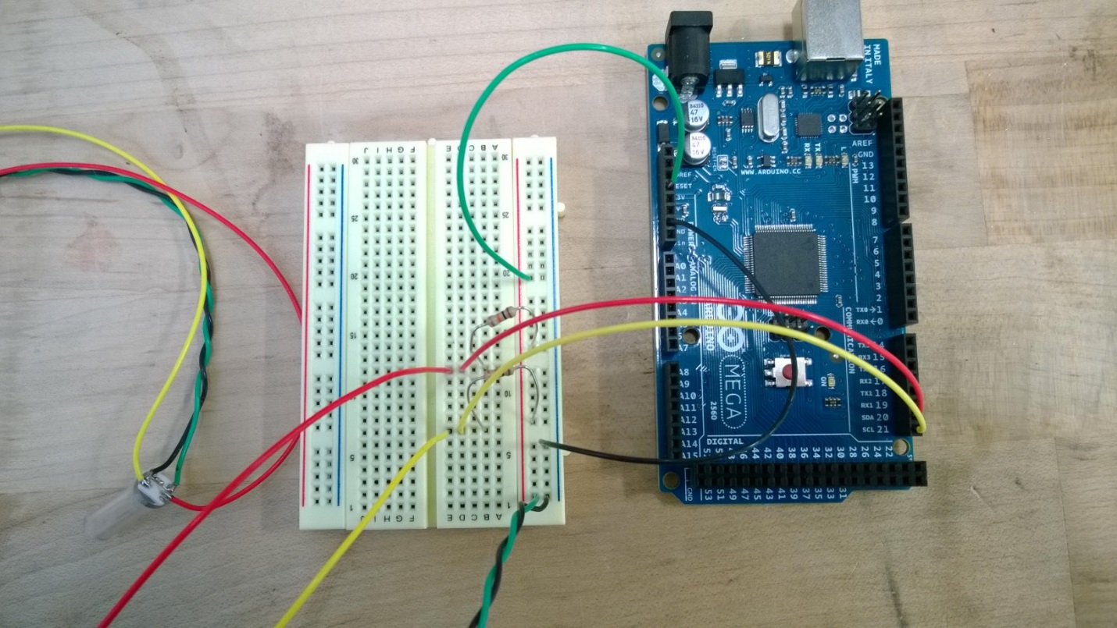

Figure 1 MS5803 wired for I2C to Arduino Mega

The MS5803 communicates over serial using an I2C interface. The Arduino Mega transmits and receives data from the depth sensor and sends a stream of updated time (ms), temperature (°C), and pressure (mbar) measurements over serial to be stored.

The depth sensor is tested at discrete pressures: starting at ̴1013.3mbar (1 atm) and ending at ̴ approx. 1094.9mbar.

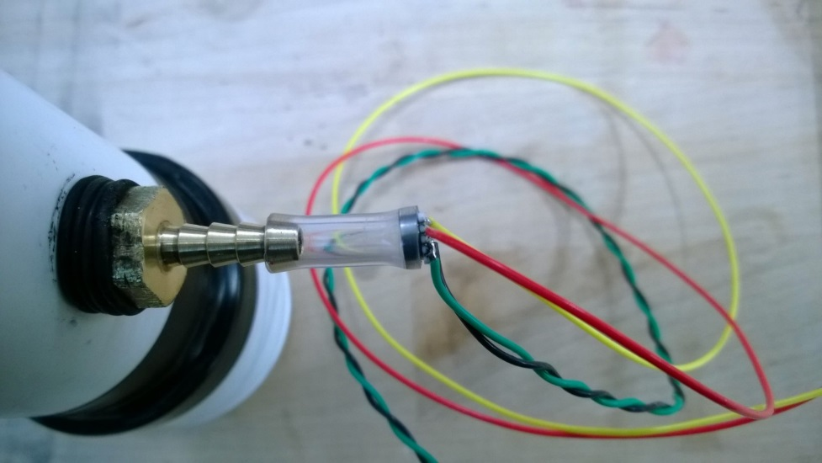

Figure 2 MS5803 fit to the reservoir

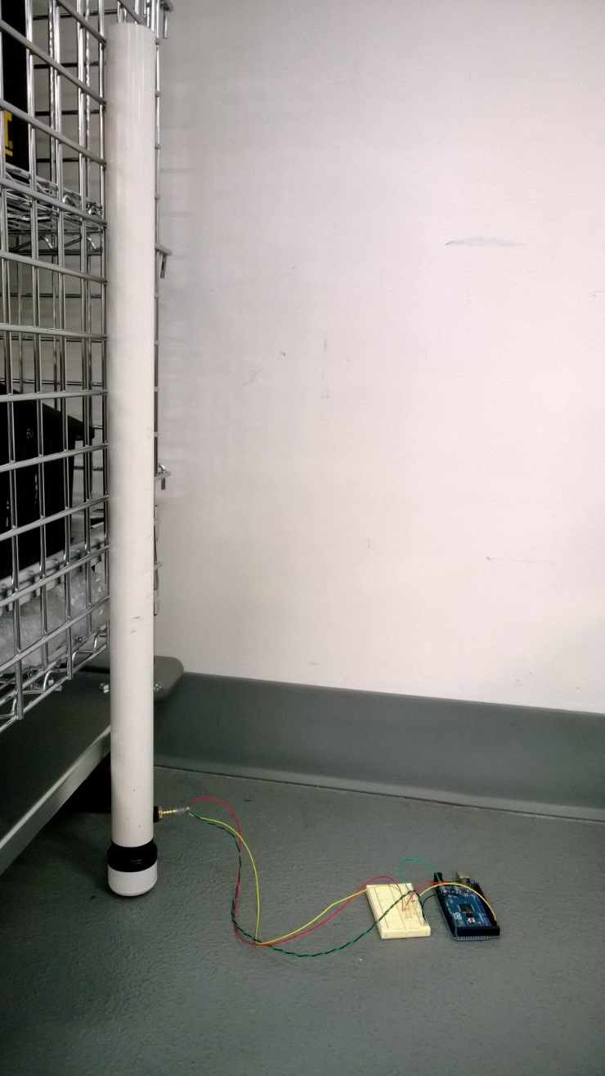

Figure 3 Experimental Setup

## Test Procedure

Testing proceeded as follows:

* Start serial communication with Arduino Mega/depth sensor and start logging the data stream.
* Begin with the depth sensor open to the atmosphere, record the sensor measurements for approximately 100 minutes, in order to observe stability, precision, and accuracy.
* Attach the depth sensor to the empty reservoir via a barbed fitting, log data for 30 minutes.
* Ramp pressure by pouring water into the reservoir. Log data for each ramp.
* Once reservoir has been filled and the data logged for this maximum pressure, empty the reservoir and start logging depth sensor measurements back at 1 atm.

Ten runs are performed and are detailed, in the order they were executed, in Table 1.

Table 1 Description of Runs

|  |  |  |
| --- | --- | --- |
| Run | Pressure | Log Filename |
| 1 | atm | atmA |
| 2 | atm, fit to reservoir | baseA |
| 3 | Pour 1 | pour1A |
| 4 | Pour 2 | pour2A |
| 5 | Pour 3 | pour3A |
| 6 | Pour 4 | pour4A |
| 7 | Pour 5 | pour5A |
| 8 | Pour 6 | pour6A |
| 9 | Pour 7 | pour7A |
| 10 | atm | base_postA |

The first test is run with the MS5803 open to the atmosphere, not yet fit to the reservoir (See Figure 1). Data is acquired over a period of 100 minutes in order to observe the long-term stability of the sensor. The ¼” OD vinyl tubing is placed over the pressure transducer’s aluminum housing, such that the inside of the housing center can move freely. The seal between the tubing and pressure transducer is confirmed to be able to withstand the pressure that is seen by the transducer throughout this experiment.

The second test is run with the MS5803 fit onto the barbed reservoir outlet (See Figure 2). The reservoir is empty, so the pressure seen by the sensor should agree with the results from run 1. The reservoir is then filled to check for leaks. Once it is confirmed to be leak-free, the reservoir is leveled and zip tied to the cage (See Figure 3).

For runs 3-9 the pressure seen by the transducer is gradually increased by increasing the height of the water column within reservoir. Approximately 175mL of water is added to the reservoir for each run, except for run 9. The actual pressure seen by the sensor is calculated using the height of the water column relative to the height of the sensor. Run 10 is a final test at atmosphere to ensure that the pressure transducer is still performing to specifications.

# Results

The data from the tests are stored in the folder:

P:\Projects\ADAPT\6 Testing\MS5803-14BA\10-11-2013 Test

See Table 1 for descriptions of the different data files within the folder.

## Depth Sensor Performance

The major results are summarized in Table 2 and presented graphically in Figures 4 and 5.

|  |  |  |  |  |  |
| --- | --- | --- | --- | --- | --- |
| **Run** | **Actual Pressure (mbar)** | **Measured Pressure (mbar)** | **Pressure from Delta P (mbar)** | **Pmeas - Pact (mbar)** | **Pdelta-Pact (mbar)** |
|
| 2 | 1013.3 | 1012.6 | 1012.6 | -0.65 | -0.65 |
| 3 | 1016.9 | 1021.1 | 1016.8 | 4.22 | -0.08 |
| 4 | 1032.9 | 1035.9 | 1033.0 | 3.03 | 0.13 |
| 5 | 1045.6 | 1044.2 | 1045.8 | -1.42 | 0.18 |
| 6 | 1060.0 | 1057.4 | 1060.4 | -2.64 | 0.36 |
| 7 | 1070.8 | 1066.7 | 1070.6 | -4.13 | -0.23 |
| 8 | 1088.1 | 1082.4 | 1087.3 | -5.70 | -0.80 |
| 9 | 1094.9 | 1089.1 | 1094.0 | -5.77 | -0.87 |

The actual pressure is calculated by measuring the height of the water column, and using . The measured pressure is the output from the MS5803, after temperature compensation. Pressure from ΔP is calculated using the previous “Pressure from ΔP” and adding the change in pressure recorded by the transducer due to actual pressure increase. This change in pressure can be seen in Figures 8-15.

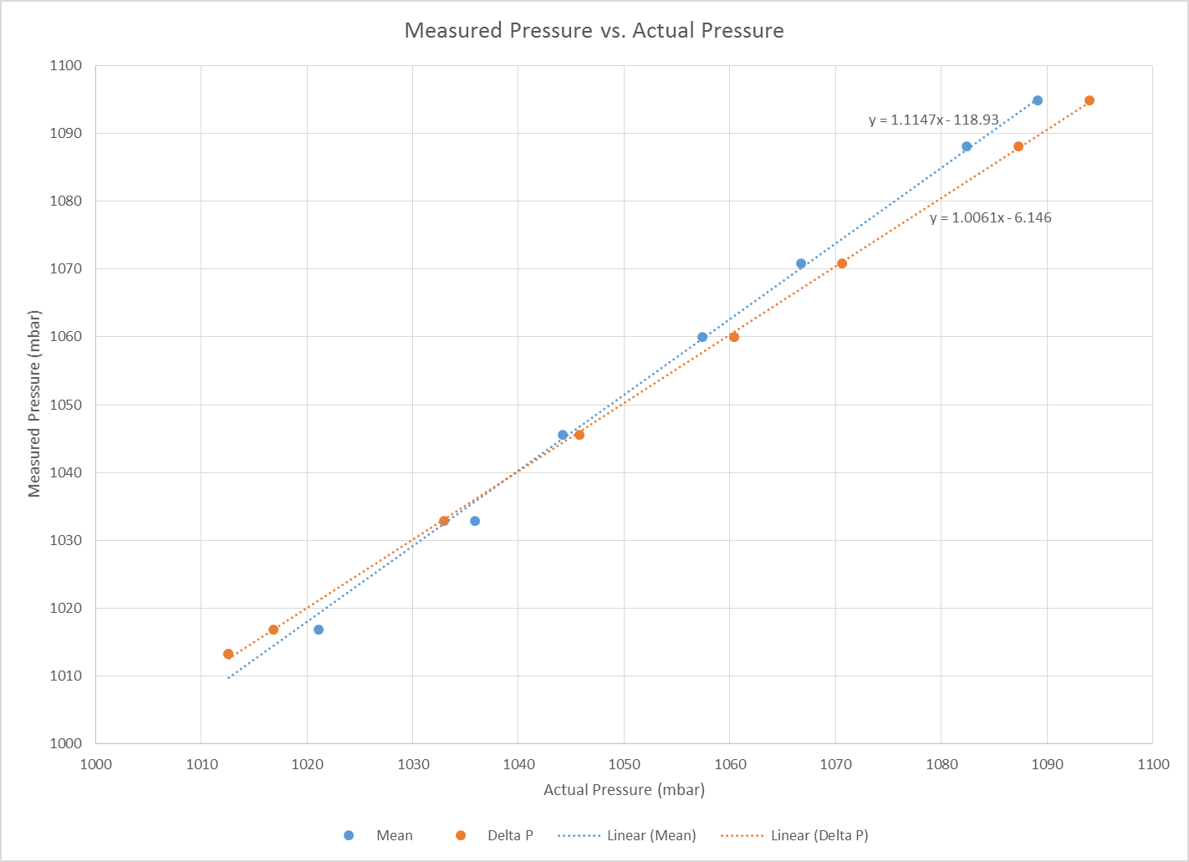

Figure 4 Measured Pressure vs. Actual Pressure Plot. "Mean" refers to the pressure measured and averaged over the sample period. "Delta P" refers to the pressure calculated using the change in pressure due to the ramped pressure input.

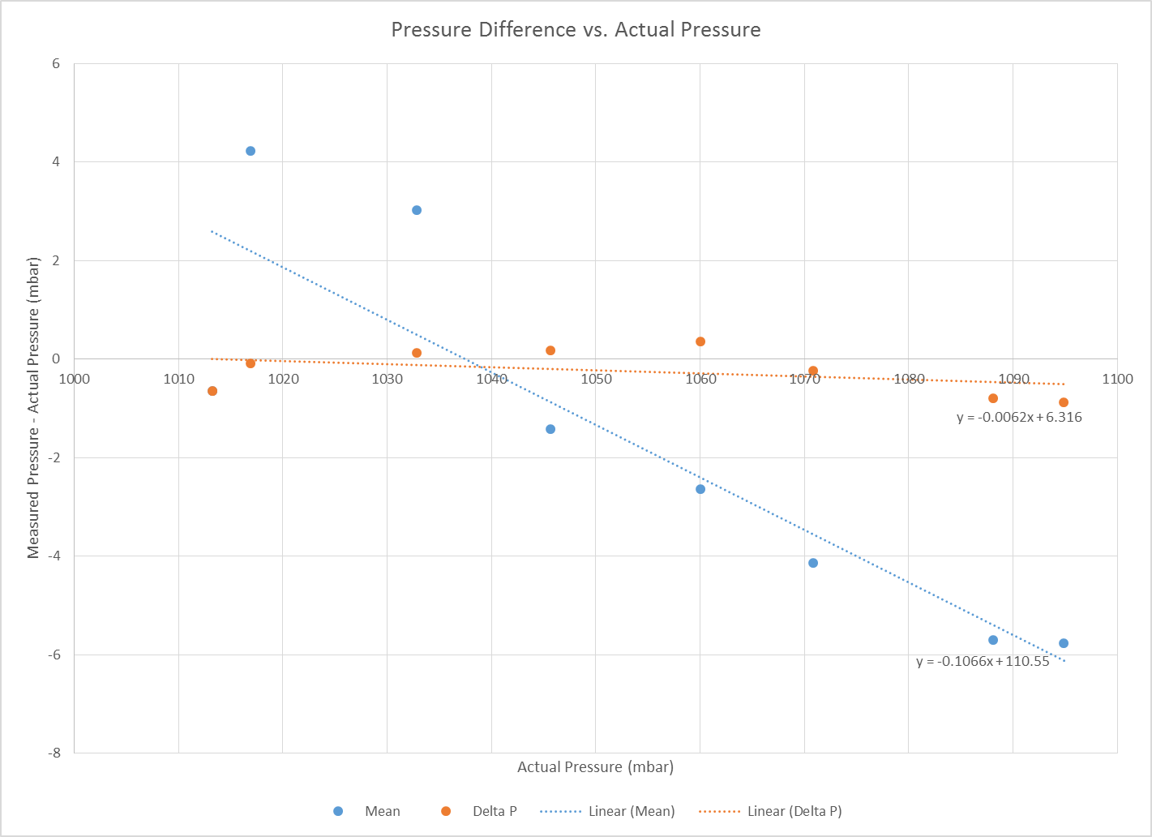

Figure 5 Measured Pressure minus Actual Pressure vs. Actual Pressure. "Mean" refers to the pressure measured and averaged over the sample period. "Delta P" refers to the pressure calculated using the change in pressure due to the ramped pressure input.

## Depth Sensor Experimental Results

Run 1 results are presented in Figure 6. The actual pressure seen by the transducer should be approximately 1013.25mbar. The mean measured pressure is 1013.8mbar. This is well within the transducer’s accuracy of ±20mbar. The standard deviation from the mean is 0.47mbar and the maximum difference in pressure readings is approximately 3mbar. The precision of the sensor given the results is 0.1154mbar.



Figure 6 Run 1 (transducer at atm)

Run 2 results show greater oscillations in the pressure measurement (Figure 7), ranging from 1009mbar to 1019mbar. This is within the range of expected sensor accuracy. The mean pressure measured for this run is 1012.6mbar and the precision is 0.1161mbar.



Figure 7 Run 2 (transducer at atm, fitted to reservoir)

Run 3 tested the transducer at a pressure of approximately 1017mbar. The sensor’s response to the addition of pressure can be seen at the start of the run. Both the mean of the resultant pressure, 1021.1mbar, and the change in pressure before and after the ramp input, 3.63mbar, are used to calculate the measured pressure of the system. This procedure is done for runs 3-9. The output response has a standard deviation of 0.8922mbar and a precision of 0.1113mbar.



Figure 8 Run 3 (Pactual = 1017mbar)

Run 4 increases the pressure of the system to 1033mbar. The mean measured pressure is 1035.9mbar and the pressure using ΔP is 1033mbar. The measurement’s standard deviation is 1.7401mbar and its precision is 0.1122mbar.

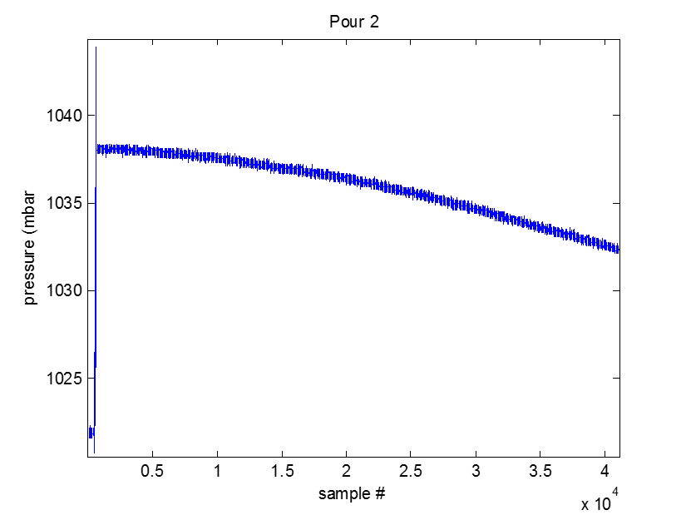

Figure 9 Run 4 (Pactual = 1033mbar)

Run 5 increases the pressure of the system to 1046mbar. The mean measured pressure is 1044.2mbar and the pressure using ΔP is 1048.8mbar. The measurement’s standard deviation is 0.3377mbar and its precision is 0.1148mbar.



Figure 10 Run 5 (Pactual = 1046mbar)

Run 6 increases the pressure of the system to 1060mbar. The mean measured pressure is 1057.4mbar and the pressure using ΔP is 1060.4mbar. The measurement’s standard deviation is 0.2772mbar and its precision is 0.1186mbar.



Figure 11 Run 6 (Pactual = 1060mbar)

Run 7 increases the pressure of the system to 1071mbar. The mean measured pressure is 1066.7mbar and the pressure using ΔP is 1070.6mbar. The measurement’s standard deviation is 0.186mbar and its precision is 0.1181mbar.



Figure 12 Run 7 (Pactual = 1071mbar)

Run 8 increases the pressure of the system to 1088mbar. The mean measured pressure is 1082.4mbar and the pressure using ΔP is 1087.3mbar. The measurement’s standard deviation is 0.3424mbar and its precision is 0.1088mbar.



Figure 13 Run 8 (Pactual = 1088mbar)

Run 9 increases the pressure of the system to 1095mbar. The mean measured pressure is 1089.1mbar and the pressure using ΔP is 1094mbar. The measurement’s standard deviation is 0.2614mbar and its precision is 0.1067mbar.



Figure 14 Run 9 (Pactual = 1095mbar)

Run 10 polls the transducer post-experiment, when the transducer is exposed to only atmospheric pressure. The mean measured pressure is 1009.6mbar. The measurement’s standard deviation is 1.6911mbar and its precision is 0.1072mbar.



Figure 15 Run 10 (transducer at atm, fitted to reservoir)

## Temperature Effects of Pressure Measurement

The effects of temperature on the pressure measurement is also investigated. Figures 16 & 17 present transducer output results given temperature fluctuations. In figure 16, the effect of temperature on pressure is not clear. Figure 17 appears to confirm the relationship between the two measurements.



Figure 16 Pressure and temperature vs. time



Figure 17 Pressure and temperature vs. time

# Discussion

## Summary of Test Results

Testing of the MS5803-14BA depth sensor showed the following:

* The error in the depth sensor pressure measurement is as little as -0.6% of the actual pressure under ideal temperature conditions.
* The error in the depth sensor pressure measurements did not exceed ±6mbar.
* The precision of the sensor remained consistent regardless of the pressure seen by the sensor and averaged 0.1129mbar ±0.013.
* Temperature had a small, linear effect on the pressure measurement.

## Impact on Vehicle Performance

The MS5803-14BA performs according to specifications given the results from this testing. Therefore, this sensor can be used to achieve the required 0.5m rms accuracy for depth sensing.

# Conclusions

The results indicate that the MS5803-14BA is consistently performing better than specifications, under ideal temperature conditions around 22°C. The accuracy of the transducer remained within ±6mbar, and precision averaged 0.1129mbar ±0.013. Temperature fluctuations as little as 0.5-1°C cause pressure (mbar) to fluctuate with the same trend, at about half the rate of change.

# Appendix A: Additional Results

|  |  |  |  |  |
| --- | --- | --- | --- | --- |
| **Pressure (mbar)** | **mean (mbar)** | **std** | **variance** | **delta P (mbar)** |
| **atm** | 1013.8 | 0.4676 | 0.2186 |  |
| high frequency |  | 0.1154 | 0.0133 |  |
| **attached to reservoir** | 1012.6 | 2.7963 | 7.8191 |  |
| high frequency |  | 0.1161 | 0.0135 |  |
| **pour 1** | 1021.1 | 0.8922 | 0.7961 | 4.2 |
| high frequency |  | 0.1113 | 0.0124 |  |
| **pour 2** | 1035.9 | 1.7401 | 3.028 | 16.2 |
| high frequency |  | 0.1122 | 0.0126 |  |
| **pour 3** | 1044.2 | 0.3377 | 0.1141 | 12.8 |
| high frequency |  | 0.1148 | 0.0132 |  |
| **pour 4** | 1057.4 | 0.2772 | 0.0768 | 14.6 |
| high frequency |  | 0.1186 | 0.0141 |  |
| **pour 5** | 1066.7 | 0.186 | 0.0346 | 10.2 |
| high frequency |  | 0.1181 | 0.0139 |  |
| **pour 6** | 1082.4 | 0.3424 | 0.1173 | 16.7 |
| high frequency |  | 0.1088 | 0.0118 |  |
| **pour 7** | 1089.1 | 0.2614 | 0.0683 | 6.7 |
| high frequency |  | 0.1067 | 0.0114 |  |
| **post base** | 1009.6 | 1.6911 | 2.8598 |  |
| high frequency |  | 0.1072 | 0.0115 |  |

|  |  |  |  |  |  |
| --- | --- | --- | --- | --- | --- |
| **Run** | **Actual Pressure (mbar)** | **Measured Pressure (mbar)** | **Pressure from Delta P (mbar)** | **% Error (Pmeas)** | **% Error (Pdelta)** |
|
| 2 | 1013.3 | 1012.6 | 1012.6 | -0.06 | -0.06 |
| 3 | 1016.9 | 1021.1 | 1016.8 | 0.42 | -0.01 |
| 4 | 1032.9 | 1035.9 | 1033.0 | 0.29 | 0.01 |
| 5 | 1045.6 | 1044.2 | 1045.8 | -0.14 | 0.02 |
| 6 | 1060.0 | 1057.4 | 1060.4 | -0.25 | 0.03 |
| 7 | 1070.8 | 1066.7 | 1070.6 | -0.39 | -0.02 |
| 8 | 1088.1 | 1082.4 | 1087.3 | -0.52 | -0.07 |
| 9 | 1094.9 | 1089.1 | 1094.0 | -0.53 | -0.08 |

# Appendix B: MS5801-14BA DataSheet

Double-click image for full PDF of data sheet

